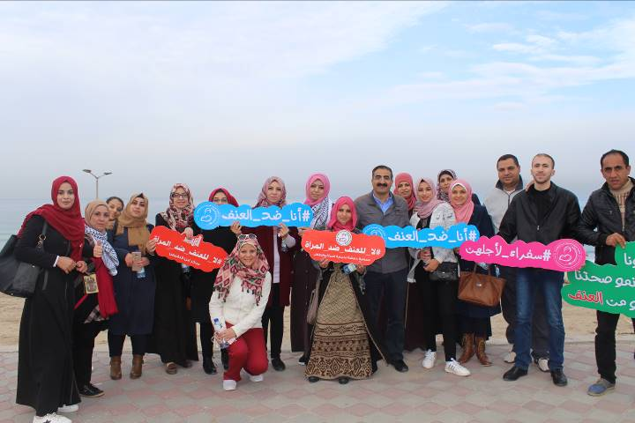
AISHA Annual Report
2017
جمعية عايشة لحماية المراة والطفل | 4/2/18 | فلسطين - قطاع غزة

Content
Introduction 2
Board of Directors 2
Human Resources 4
Financial and purchases department 5
Public & International Relation 5
projects 6
Challenges 24
Future needs 25

Introduction
The humanitarian situation in the Gaza Strip is the most important challenge facing human rights in Palestine and the Gaza Strip, especially women and children. Despite these challenges of occupation, siege and political division that hinder the development process, Aisha has continued to provide quality services for women and children in the strip through a series of projects to achieve unique goals. The Palestinian women also achieved their utmost to support and protect their rights and hopes as well as strive with great efforts to open horizons that can respond to their dreams for a secure and future life in which they can enjoy happiness and stability.
In its seventh year, Aisha has rewarded its success with a two-year commitment to the Code of Conduct for Palestinian NGOs, which is awarded to institutions that adhere to transparency, integrity, development priorities and other values. The Association also completed this year the protocol of Aisha Community Center to provide mental health services and addiction treatment for women and children in Gaza strip, the first clinic at the local level for addiction treatment and providing specialized psychological services for women and children in the Gaza Strip. Aisha also established a research department that produced qualitative research on women's access to justice in the Gaza Strip and studied the attitudes of men and children about violence against women in the Gaza Strip. The Association provided various programs to approximately 15,000 women, men, children and young women as direct beneficiaries by great efforts of the administrative, financial and professional staff, as well as many volunteers and trainees, under supervision of the Board of Directors.
Hoping to have a new change every year of development, promotion and protection of human rights.

The board of director:
The council speech:
With the end of our three-year electoral cycle, we thank you for your trust in us throughout the previous period. We hope that we have fulfilled our commitment and performed well during the previous period. The level of services offered by the Association to vulnerable groups and marginalized areas, especially women, children and families affected.
The Association also improved the administrative aspect in terms of preparing regulations, policies and plans and approving them in order to develop the performance of the work towards a more fair, transparent and clear work.
We are honored to have a certificate of commitment to the principles of the Code of Conduct for two years, issued by the NDC . As well as designation Aisha as the Ambassador of the Palestinian Paltel Group Award for Excellence and Creativity of 2018.
In addition to the expansion of external and internal relations and getting approval of many important and distinctive projects, which reflect in essence the state of growth and development in the performance and reputation of Aisha. Expanding its work by providing a greater psychological health service for women in the near future to become one of the important health institutions through opening Aisha Community Center for mental health and addiction treatment.

As we conclude our electoral cycle and we feel proud to belong to this association, We have come to become one of the important women's association, this cannot be achieved except by the efforts between the Board and the executive management represented by the senior management and staff who have made a wonderful effort to promote the Association. By feeling of national and social responsibility and sensitive human sense towards the issues of our people and the problems of our Palestinian society who is living the most difficult conditions
Our confidence in the next Council is high that it will proceed steadily towards the advancement and progress of Aisha.
Thank you and all respect and appreciation to all of you.

The member of the board:
- Mr. Ilias Al Jelda Chairman of the board
- Mr. Khalil Shaheen Deputy of chairman of the board
- Mrs. IbtisamDaloul Chief Treasurer
- Mrs. TaghridJoumaa' Secretary General
- Mr. Rafaat Salhaa Member
- Mrs. Itaf Al Khatib Member
- Mrs. Majda Shaheen Member

Meetings of the board of directors and the general assembly:
  - Meeting of General Assembly
The ordinary meeting of the General Assembly was held on Monday, 17/7/2017 at the headquarter of Aisha, attended by 27 members out of 48 members of the General Assembly. The Chairman presented a summary of the administrative report for the year 2016. The meeting discussed and approved the administrative and financial reports and selected of the audit company accounts for the year 2017.
The Assembly also held an extraordinary meeting on Sunday 07/05/2017 in the presence of 33 members out of 48 to make amendments to the statute of the Assembly where it has been approved to update the terms of the scope of the work of Aisha and add a strategic goal of providing specialized psychological services for women. The Association has obtained the license from the Ministry of Interior for Aisha Community Center for Mental Health and Addiction Treatment, an amendment to the terms of membership and the end of membership

  - Meeting of Board of Directors
During the year 2017, the Board of Directors held a total of 12 meetings in which Aisha's affairs were discussed in relation to the employees, projects and the financial status of the Association. The most important thing during the meetings of the Board was the discussion and approval of the current projects on the ground, as well as projects calling of funding and appointments to the projects, The Council has contributed to the development and adoption of five policies, namely the gender mainstreaming policy, the fight against corruption, volunteerism, the child protection policy and the Code of Conduct. The Council has been keen to ensure fairness and transparency in all procedures and policies relating to all previous matters, Also the daily work with the executive management.

Human Resources:
As for the employees of the Association, there were 32 employees, including 20 main administrative employees of the Association, 12 employees on projects.
The Association has a distinguished team, some of them are international trainers in the fields of positive education (2 female employees), well-being and integrated security (2 female staff), the Sykdarama (4 female employees), respectful confrontation (3 employees) engaging men in the fight against violence against women (8 women and 10 ambassadors from the anti-violence ambassadors), four of them received the name of a professional supervisor in the field of mental health as part of the program of professional supervision implemented by the GCMHP for the third year in a row.
In addition, two recently received a master's degree in mental health and human resources management, two enrolled in the master's program in the field of mental health, another received a doctorate in social work specializing in family therapy and two concluded a diploma in secretarial and English.
It should be noted that the number of volunteers reached (6) volunteers during the year 2017 in the various fields of "management, projects, social service, accounting and secretarial." The number of trainees of university students (Al-Azhar, Islamic, Jerusalem, Al-Aqsa) reached to 70 trainees in the fields of psychology and social service and management degree of diploma and bachelor's and master's. The Association has received more than 25 graduates as part of the operating programs offered by Islamic relief organizations, together with Catholic Relief in the professional and administrative fields
Financial and purchases department:
2017 witnessed a rapid and growing movement of financial transactions and procedures and contacting new projects which added more experience to the financial department, with the help of the financial auditor and consultant hired by the association for the development of the financial system to meet the requirements and the level of work and the size and quality of the projects and funding.

Despite the lack of human staff at the financial department, it proved its ability to implement financial transactions and procedures according to the rules of procedure, it could plan budgets for projects and submitted high-quality reports to the Board of Directors and fundraising without delay. It developed the Department to comply with the requirements of funding and international standards of auditing .
As a result of high volume of work and high number of project coordinators, the Finance Department implemented financial training for all project coordinators and field coordinators. These procedures are to be followed to follow up the disbursement of activities within the budgets of projects in order to increase efficiency in work and quick completion of financial transactions related to projects.
Project management and fundraising department:
Since establishing Projects and Fundraising Department, the Department has maintained a specific level of projects managed annually which has not less than ten projects per year and has established strategic partnerships with international donors. "Kevvina til Kevvina, UN Women, German Cooperation, The United Nations Development Program (UNDP) and others. "
During 2017, Aisha provided 62 funding project proposals in response to funding calls from partners or funding institutions that Aisha has never dealt with, as well as several concept papers for small funding proposals to fund simple initiatives supporting key programs in the Aisha. The Department has succeeded to obtain funding for 14 projects submitted by which two projects will be implemented during 2018-2019
Public and international relations:
The impact of the siege was clear to this circle, where only contact with donors, partners and friends via e-mail, Skype conversations or video conferencing. In spite of this, Aisha has contributed to many local and national conferences and workshops, as well as evaluation sessions, networking through Skype or video conferencing.

Projects

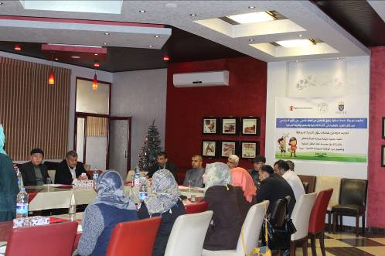
First project/ Protection of children from Gender-Based Violence through the Promotion of their Sexual Health Rights
- Date: 01/01/2017 - 31/12/2017
- Place: North Gaza, Gaza city
- Beneficiaries: 160 of children, 320 parents, 40 service providers
- Fund: Save the Children
- Bugget: 55.456 $

- The activities implemented during the reporting period:
- Conducting 288 awareness sessions for 525 children aged 10-17 on the first, second and third manual on reproductive and sexual health by the service providers and Aisha staff (24 groups of 12 sessions per group).
- Conducting 168 awareness sessions for 249 people on the first, second and third reproductive and sexual health manual by the service providers and the staff of the Aisha Association (14 groups per group).
- Conducting 144 awareness sessions on Positive Education (PD) with parents (18 groups - 8 groups each).
- Implementing of 18 follow-up sessions of 338 parent for each group of positive education groups (18 groups _ each group 1 session).
- Refer 42 cases of psychiatric treatment to Aisha Community Center, then transferring severe cases to Gaza Mental Health Program or other institutions for additional services.
- Conducting 3 training targeting more than 60 one from the community service providers on the first, second and third manuals in the Gaza Strip and northern.
- Implementing of 2 training targeted more than 40 one from service providers on positive education in the Gaza Strip and North and Central.
- Implementing of 4 legal sessions of partners from civil society to discuss the developments of the project and its results and follow-up activities.
- Conducting 1 dialogue sessions for 272 children, parents and service providers.
- Follow-up of 10 information centers in UNRWA clinics established in previous years from 2014 to 2016 in selected areas on children's reproductive health rights.
- Implementing an information campaign # Our children is the secretariat of the first phase of the promotion of children's rights in reproductive health and positive education.
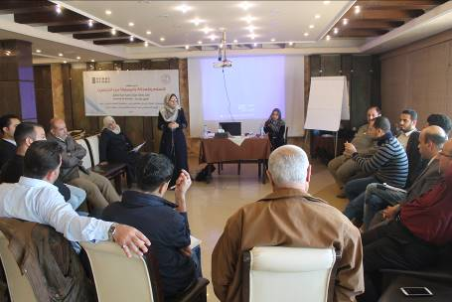
Second Project/ Engaging men and boys in promoting gender equality and non-violence in the Gaza Strip"
The project aims to engage different actors and individuals in the Palestinian Society’s in Gaza and increase their contribution towards supportive environment for the protection and promotion of women rights and gender equality in the five districts of the Gaza strip. This will be done through engaging 75 men from different occupations and social backgrounds to create new model of women rights defender through forming group of men ambassadors to combat violence against women and promote gender equality. The project specific objective is to Discrimination against women and entitlement to the use of violence as a means to resolve conflicts is less accepted in the targeted communities
- Date: 1/1/2017 – 31/12/2017
- Place: Gaza Strip
- Beneficiaries: 75 ambassadors
- Fund: Kivvena till Kivvena
- Budget: 91.544 $

- The activities implemented during the reporting period:
- Establish research entitled "Shifting Perspectives: Engaging men and boys in addressing GBV against women and girls in Gaza Strip”
- Design and print the research (1000 copies)
- Publish the research in a conference in the attendance of 200 persons from community leaders, service providers, Human and woman rights organizations, women, men
- Organize (15) follow up meetings (one meeting every 4 months\ group) for the ambassadors in each district (5 groups) to discuss the project activities and provide their suggestions and ideas to contribute in enhancing the project.
- Organize (2) workshops (one each 6 months) for all the ambassadors to discuss gender issues and gender transformative approaches
- Development of (3) training material/modules (each module contains 2 trainings) by trainers, and printing (200) copies of each training module. Final version of the material will be issued after consulting all the trainers.
- Conduct training of trainers for Members of the 5 Ambassador Groups including: Training I (respectful confrontation), Training II (Gender Transformative Programs and Approaches), Training III (Musawah training), Training IV (advocacy using electronic platforms / social media), and Training V (Strategic Planning).
- Organize workshop 1 in each district to develop outreach plans and budgets (5 plans and budgets developed).

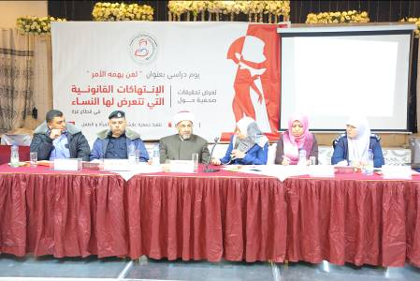
Third Project/ Towards the Legal Empowerment of the Community in Support of Women's Legal Rights To support the legal empowerment of the community to promote access to justice and security for women victims of violence by strengthening legal intervention in the Gaza Strip
- Date: 1/9/2017 – 28/2/2018
- Place: Eastern and northern Gaza
- Beneficiaries: 6120
- Fund: UNDP
- Budget: 60.000 $

- The activities implemented during the reporting period:
- Representing (70) women legally before the sharia courts and referring (10) cases to AWN partners . Providing (300) individuals’ legal consultation and mediation on women legal rights and access to justice.
- Conduct (25- hour) Capacity Building for 25 schools’ Teachers and Counselors from Gaza
- Organize Phase II of the Advocacy Campaign:
- To complement the implementation of “My kids Need Me” campaign during the two months which began in the previous4 months . Aisha Association with cooperated with the Ministry of woman’s affairs where it is considered the only ministry affiliated to the Government of Reconciliation also the ministry has made previous efforts to pressure to change the custody age for widows women.

- A Booklet has been developed in order to clarify all the determinations that women faced in custody cases with a fully-detailed 5 case studies about 5 women suffering from the valid Custody Law, and how these 5 women lost their right of child custody due to this Law, Aisha designed and printed 500 copies from these booklets and had been distributed to many women organizations , human rights organization , lawyers and decision makers , also Aisha sent hard copies from it to the highest Supreme Council of the Judiciary at Ramallah and Gaza in order to consider ways of accelerating action to unity reconciliation to change all the personal status law and custody law as well .
- And to reach out to the public on25thFebruary 2018, a radio episode aired through Watan Radio stations, tackling “My Kids Need Me” campaign’s results, hosting the legal clinic lawyer Ms. Asmaa Abu Lehya and project Coordinator Marwa Olwan. They also stated that the campaign will continue until the current custody law has changed. they indicated that Aisha’s Association received all custody cases whether it’s legal, social or psychological.(Stationaries and hospitality provided during the study day).
- Produce A Booklet Including (6) Investigative Reports on Violations of Women’s Rights.
- A MOU is drafted and signed between Aisha and Community Media Center-CMC in Dec., in the aim of getting specialized journalist product in this activity. CMC provide 6 journalists to achieve professional investigations, in cooperation with Aisha’s lawyers. 5 written investigative reports and one video report done early in February. The investigation designed and printed in pamphlets and 500 copies had been distributed to human rights organizations, police officers, lawyers and women organizations, where it aims to focus on the most issues facing women at Sharia courts. The investigation reports presented in the Study day later aiming at spot the light on the addressed issues.
- Organize A Study Day Workshop Presenting the Investigative Reports
- After the completion of all the investigative reports, workshop was held at International Gaza Hotel on 28th February 2018,more than 80 human rights organization, women’s right organization, and jurists were attended these workshop, where a number of officals were hosted and discussed the 5 investigation reports with the concerned officials , ( the president of the supreme council of sharia courts Hassan AlJuju , public relation manager at police offices Mr. Emad Alamassi , Family and child unit officer Mariam Al Bursh and the director of the judicial police Mr. Ibrahim Abu Eliss , (alimony fund – delay in judicial documents -Complaints submitted by victim women are transferred from prosecution office to public relations departments at police station -divisive conflicts cases – Linking alimony rights with the husband badly financial situation).A Video about homeless kids as a result of parents separation was shown.
- 2 round tables have been replaced with one study day after UNDP confirmation because of the difficulty of the present time (Unity Reconciliation) where there are many challenging with coordination with the two Supreme Council of Islamic Jurisdiction in Gaza and West bank and the absence of the Legislative Council who are the responsible for changing the current custody law. a study day conducted on 12 February 2018 , and copies distributed to women and child rights organizations , where Mr. Mohammed Abu Hashem who has prepared the 5 case studies , introduced the studies in details and discussed each of legal , social and psychological determinations that affecting both of women and children , and he presented the study’s recommendations . Amira Haron The Deputy Minister for Women Affairs welcomed Aisha’s role in promoting the women and children rights, Where Aisha had been prepared a draft law for Custody law as to be presented to authorities with promote the unifications of law.

Media coverage for all Zakher activities
Zakher association had been professionally completed on 2 radio episodes about:
- The Role of Prosecution and legal procedures which being applied in the Gaza Strip and mechanisms to defend them.
- The Role of schools on how to deal with juvenile children from the social and community perspective.
A Face book page (paid) has been built in order to raise legal awareness of juvenile child and to address such rights as a public debate.
A documentary film has been completed as planned. All activities, outputs, case studies, types of crimes that children might fall in, procedures of investigation and police centers and final destination like court and prison where highlighted in the film. Finally, recommendations from lawyers where were on the site. Key recommendations came from the lawyers like:
  - Necessity to extend project activities to include all ages of children in order to maximize the benefits and raise legal awareness of the children all over the Gaza Strip either at schools or inside rehabilitation/jail centers.
  - Necessity to raise public awareness on the children crimes that the Palestinian basic law punish.
Necessity to enrich the Palestinian curriculum to include children rights as a basic subject to be taught at schools in order for the children to avoid attacking crimes without knowing the consequences

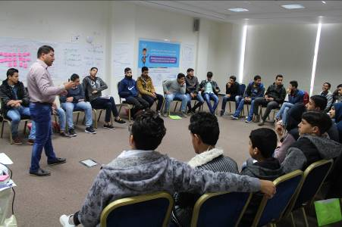
Forth Project/ Shifting perspectives of men and boys of Masculinity and Gender Equality

The project focus on the idea of “To speak of masculinities is to speak about gender relations. Masculinities are not equivalent to men; they concern the position of men in a gendered order. They can be defined as the patterns of practice by which people (both men and women, though predominantly men) engage that position. The main idea of the prject is to creat a group of Gender Equality promoters from adolesconts within the boy’s secondary schools students as agent of change in their local communities to promote Gender Equality and changing face of Masculinity among their peers through developing their skills in addressing gender issues and organizing set of initiatives. The project will contribute to achive the general goal of UNWOMEN program “the role of men and boys in gender equlity and the changing face of masculinity”. The project specific goal is Men and boys have become more effective change agents in and promoting gender equality and this goal will be achieved via two outcomes 1) Knowledge, skills and attitudes of men and boys supportive to women's rights and promoting gender equality and changing face of masculinity. 2) Community changes attitudes and beliefs on Masculinity and Gender equality.
- Date: 1/6/2017 – 30/11/2018
- Place: Gaza Strip
- Beneficiaries: 1000
- Fund: UN Woman
- Budget: 37.000 Shekel
The project target groups is 1000 adolescent from Boys’ secondary school students, 100 out of them will form the 5 promoters’ groups and will attend capacity building training and organize community initiatives among their peers. In addition to 600 persons from their parents and teachers will attend awareness workshops about masculinity and gender equality.

- The activities implemented during the reporting period:
- Form an advisory committee to manage the training process composed of consultants and experts in the field of gender, combating gender-based violence, members of secondary schools and the Ministry of Education.
- Conduct a baseline survey on the attitudes of boys’ secondary schools tenth grade students to learn about their knowledge about gender and masculinity, their visions and their and to identify intervention areas and develop the guidance manual based on the survey results.
- Prepare a manual on “Transforming masculinities and engaging boys and men in women’s rights and gender justice” for youth, adolescents, and parents on GBV, Masculinity, and gender equality via a creative gender equality program, including two guide books "General Guide, Guide for Gender Equality Promoters".
- Select (20) boys’ secondary schools- tenth grade to conduct the program within them based on the result of the baseline survey.
- Capacity building training for (40) schools’ male teacher of tenth grade on the use of “Transforming masculinities and engaging boys and men in women’s rights and gender justice” manual. (2 groups, 30 hours / per group) on 1) gender, gender equality, GBV. 2) Masculine principles, reframing power, what it means to BE A MAN 3) Emotional life of men, examining power and relations and understanding violence, where the purpose of training the 40 male teachers is because they will be managing the students’ initiative. In addition, the teachers and counselors will gain skills and change attitudes and can monitor violent behaviors among school students equipped with skills to resolve conflict and promote good practices.
- Conduct 240 awareness- raising sessions for 2000 boys’ secondary schools tenth grade students (80 groups), each groups will receive three sessions (4 groups\school). The session’s facilitators will be Aisha staff, ambassadors, and the session’s topics 1) gender, gender equality, GBV. 2) Masculine principles, reframing power, what it means to BE A MAN 3) Emotional life of men and understanding violence.
- Develop a tool to select Gender Equality Promoters for the program under the supervision of the project staff and the Advisory Committee and identifying (100) boys who have the will and capacity to join the GE Promoters groups.
- Conduct (5) trainings (50 hrs\training) for 100 Gender Equality Promoters, selected under activity 1.2.1, (5 groups, one group from each governorate) selected based on the tool (20-students\ group). The training hours will include life skills, communication skills, Gender equality and GBV, examining power and relations, understanding violence, what does it mean to be a man, and how to plan, design and implement initiative
- Conduct promoters exchange knowledge event (2days) aiming at presenting the initiatives results, exchange experiences between different governorates and evaluate the initiatives affect at the end of the project.
- Conduct (20) Awareness raising workshops targeting (600), parents (male and female) (each workshop 30 persons and last for 3 hours) to raise their awareness about Gender, GBV, men and boys’ engagement in changing the face of masculinity and promoting gender equality from the same selected schools.
- Conduct (5) initiatives by the Gender Equality Promoters (one Initiative\ governorate). The initiatives will utilize the various tools based on the Gender Equality Promoters group’s skills, and vision addressing the role of men and boys in promoting gender equality and changing the face of masculinity whether in their schools or their local communities.
- Conduct media advocacy campaign including production of animation film promotes engaging adolescents in changing the face of masculinity and promoting gender equality. UN Women is working on “Because I am a man” campaign so; this campaign will build on UNWOMEN campaign.
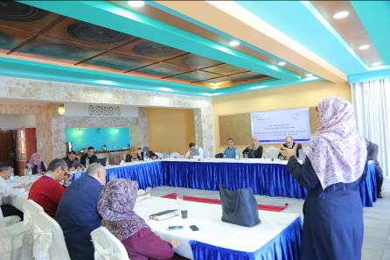
Fifth Project/ Toward a secure and just future for women
The objective of this project is to improve the access of women and girls to justice and security by ensuring accountability.
- Date: 1/10/2017 – 31/3/2018
- Place: Gaza strip
- Beneficiaries: 1582
- Fund: UN Woman
- Budget: 111400 Shekel

- The activities implemented during the reporting period:
- Conduct 150 awareness sessions for 75 groups of middle school students and 40 sessions for 20 groups of students in all governorates of the Gaza Strip. Each group received two meetings on gender-based violence and a workshop on access mechanisms for justice, in which 1582 students and 563 students participated.
- Conduct 5 dialogue meetings between students and middle school students and their families to discuss the issues of gender-based violence and the mechanisms of access to justice in which 150 one participated.
- Conduct Training on gender-based violence and access to justice for 26 UNRWA mental health supervisors and their assistants with 30 training hours.
- Conduct a dialogue meeting with UNRWA mental health supervisors and their assistants to discuss the mechanism of introducing the training subjects that they attended in UNRWA schools and future cooperation mechanisms.
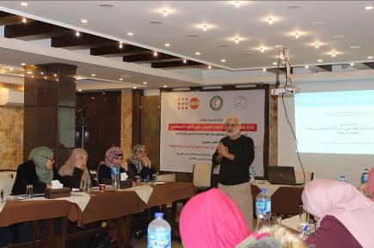
sixth project/ Protocol of Aisha Community Center for Mental Health services and Addiction Treatment
- Date: 15/5/2017 – 31/12/2017
- Place: Gaza city
- Beneficiaries: 35
- Fund: UNFPA
- Budget: 105.420 shekel
For purposes of this protocol, after reviewing many of approaches for treatment of people with substance uses, we developed this protocol to provide comprehensive care whether psychological or physical , and encourage people with substance uses to stop substance abuse with relieve pain withdrawal symptoms. In other hand, this protocol dealing with people with substance abuse in close sitting and the care extends out the center through regular follow-up. International therapeutic standards used in the development of the Protocol, it have been revised to suit Palestinian society.

Five sections in this protocol; these sections consist of guidelines to make assessment, treatment and rehabilitation toward people with substance abuse. Theses sections included mechanism of admission, assessment, management, psycho education and case management.

In first section, focused on general guidelines about rules and mechanism of admission, the people with substance abuse should understand the policies, procedures, services available, costs, client rights and all program rules.

In second section, this section offers comprehensive assessment such as past history, present history, signs and symptoms, personal history and physical and psychological assessment, these assessment help us to put strategies treatment and rehabilitation.

In third section, we deepened on international protocols in prescribing medication according to drug name, doses, frequencies and route. We make categories according to the type of substances used and degree of substance abuse.

In forth section, an evidence-based therapeutic intervention for people with substance abuse and that provides information and support to better understand and cope with health problem. Psycho education is most often associated with psychological problems such as depression and anxiety.

In five section, case management is important because, in most cases, several different people are involved in a client's comprehensive care, and they need to work together in a coordinated way. Case management as a coordinated approach to the delivery of health, mental health, and social services, linking clients with appropriate services to address specific needs and achieve stated goals.

- The activities implemented during the reporting period:
Aisha implemented the training of workers of Aisha Community Center for Mental Health and Addiction Treatment in case management and psychosocial interventions. The training course consisted of 20 training days (100 hours) covering the core subjects of the Aisha Community Center for Mental Health and Addiction Treatment Protocol. The training was aimed at increasing capacity building of professionals. The training was attended by a number of specialists from government and non-governmental actors in the field of psychosocial support for women and girls exposed to gender-based violence.
The purpose of the training is to equip the technical staff working at the Aisha Community Center for Mental Health and Addiction Treatment. The target group for interventions is women and girls who have been exposed to or subjected to gender-based violence and suffer from psychosocial-legal distress resulting from violence or psychological disorders.

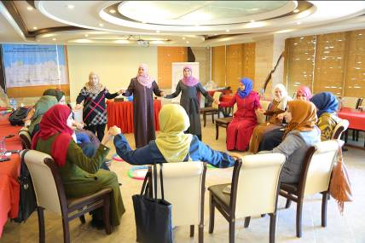
Seventh project/ Utilizing Digital Tools to Promote Human Rights and Create Inclusive Public Spaces in the Gaza Strip
- Date: 1/8/2017 – 30/11/2018
- Place: Alshouka, Wadi elsalka, Beit lahaia
- Beneficiaries: 20 female engineers, 120 youths, 1500 of local community, 1000 youths
- Fund: UN WOMEN
- Budget: 580.058.29 shekel

- The activities implemented during the reporting period:
- Selection of a number of 60 Youth and 60 adolescents (males and females with a focus on those who belong to IDP and underprivileged families(
- Conducting (50) awareness raising workshops focusing on the importance of youth and adolescents civic participation with a focus on recovery and reconstruction efforts.
- Conducting a (100) hours training course of youth and adolescents on gender equality concepts, UNSCR 1325, and GBV prevention &response (particularly protection from online bullying and sexual harassment).
- Selection of a total (20) of female architects with a focus on those who belong to IDP/underprivileged families
- Training of the (20) architects on gender equality concepts, women’s human rights, UNSCR 1325, GBV prevention, and mainstreaming protection and gender in architecture (focusing on UN Women and UN Habitat Safe Cities1model) through a (100) hours training course.
- Support creating paid job placements of (9) female architects in municipalities (following their training).
- Conducting (30) community workshops and focus groups discussions in each locality to identify the needs of women, men, boys and girls in public spaces.
- Establish (3) women and youth’s committees in cooperation with municipalities in the identified locations to guarantee women’s and youth needs & priorities addressed during the design and implementation of public spaces.
- Conducting (30) community workshops and focus groups discussions in each locality to identify the needs of women, men, boys and girls in public spaces.
- Establish (3) women and youth’s committees in cooperation with municipalities in the identified locations to guarantee women’s and youth needs & priorities addressed during the design and implementation of public spaces.
- Implement (100) awareness raising workshops engaging men and women, boys and girls, and other stakeholders on SGBV and safe access to public space
Eight project / Towards a better and safer life for women victims of violence
- Date: 1/1/2017 – 30/4/2017
- Place: Gaza and northern of Gaza
- Beneficiaries: 30 of women victims and their families
- Fund: Kivvena til Kivvena
- Budget: 29.934 $

- The activities implemented during the reporting period:
- Implementing 20 psychological support groups for 30 women victims of violence to improve well-being and integrated security.
- Implementing (10) sessions of (30) women victims of violence on the concept of gender, women's rights, communication skills, leadership and problem solving.
- Conducting (120) consultation sessions for (30) women on business administration.
- Implementing vocational training (400) hours for (30) women for 6 months on wool, cosmetics, sewing, embroidery.
- Implementهىل (4) home visits to assess the economic situation and follow-up development of the project of the beneficiaries
- Implementing (1) economic training (30) hours for (30) women on how to start income-generating project
Ninth Project/ Economic Empowerment for Women
To contribute in alleviating poverty and promoting sustainable livelihoods, self-employment and income opportunities among economically deprived and socially marginalized women in the Gaza Strip.
The Project idea is based on empower vulnerable women victims of violence psychosocially, legally, and economically, where it constitutes part of the Iceland - Palestinian Association efforts, in order to reduce the effects of blockage and the war on Gaza that resulted in horrible increase in poverty and unemployment, resulting in emerge hard challenges and difficulties faced women in Gaza strip.
The project includes two parts: the first one was the psychosocial and legal support, and the second was the vocational training and economic empowerment. Also, the targeted women victims of violence will engage in vocational training (wool, sewing, embroidery, and beauty) based on their willingness. At the same time of vocational training the women will receive trainings and sessions on (life skills, feasibility study, financial management, marketing, and any additional topics related to economic development) to help those women to grow and open independent own small project to generate income and make them empowered and independent.
Also, the project includes regular home visits for the beneficiaries to follow up their situation, these visits continue after the vocational training as a consultation during the project period.
Target group: (30) women victims of violence, widows, divorced, head of households, wives of mentally ill and drug addicted people
Location: Gaza City and the North Area
Donation: Iceland - Palestinian Association
Total Budget: 50,000 USD
Duration: one year; 1st January 2017 till 31st December 2017
- The activities implemented during the reporting period:
Conduct (20) group psychosocial support sessions for 30 women victims of violence to improve their wellbeing and integrated security.
Conduct (10) awareness sessions for women victims of violence on gender, women's rights, communication, leadership, problem solving, team work, time management, creative thinking, and self-assertiveness.
Provide (120) individual consultation sessions for (30) targeted women on business management aspects.
Conduct Technical and Vocational Training (6 months) for the selected (30) womenin sewing, embroidery, wool knitting, beauty and hear dressing
conduct home visits (4) home visits to evaluate the economic situation and follow up the project progress
Conduct (1) training courses (30 hours each) for the (30) women on how to start income generating business (entrepreneurship, feasibility study, financial management, marketing). During the training, the trainees will select their preferred businesses that fit in the market needs and carry out feasibility studies.
Select 15 innovative small businesses of targeted women who will benefit from financial assistance based on transparent criteria.
Provide financial assistance (average of 1500$ each) to the best projects (15) of the trained women to start their own projects.
Provide (4) group consultation sessions for the (15) targeted women on business management aspects.
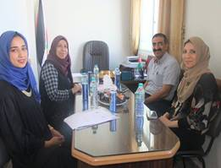
Tenth project/ Eliminating discrimination and sexual and gender-based violence against vulnerable women in marginalized communities in the Gaza Strip
The first year of the project included upgrading the IEM model used in "Aisha Association for women and child protection " the improvement of the model based on the needs of the organization and their strategy plan . The consultant that worked on upgrading the model worked on certain points regarding the organization administration , the staff including the trainers and psychologists and other staff" in addition to the used materials in trainings of any project. Beside this the first year also included need assessment for some women program centers that have old experiences with women "cases victims of violence", the main goal for the need assessment was to choose the best two centers in marginalized areas in order to move Aisha's experience in IEM model to them . The two chosen centers was "Nusirate camp one and east Gaza "Daraj". One more achievement was the needs assessment of the safe house "shelter" The purpose of this study has been to assess the organizational and women's needs in the "Safe House” in order to train the staff there in the second year of the project on IEM model which will ease their strategy of dealing with women victims of violence. Aisha also managed to conduct nearly 30 hours of training for mainly "20" women victims of violence " which was called as "women shelf help groups" these women will provide support to other women and girls victims of violence in Gaza especially marginalized areas
- Date: 1/5/2017 – 31/12/2019
- Place: Gaza strip
- Beneficiaries: 90 of women victims, 20 of women supported, 30 of service providers, 400 of local community
- Fund: Kivvena til Kivvena
- Budget: 40.000 Euro
- The activities implemented during the reporting period:
- Reviewed and upgraded the Individual Empowerment Module-IEM based on conclusions, recommendations and lessons learned from external evaluation and publish the modified IEM manual. The upgraded IEM included the group sessions' basic trainings materials on social, psychological, legal, and economic aspects. Because project mainly aims to develop Aisha's protocol (IEM Model) based on the case management. The first year included beginning of developing for the IEM Model. Based on a decision of the Board of Directors Aisha Association for woman and child protection made a direct agreement with D. Mustafa El Masry (Psychologist and consultant).
- Aisha established 2 women self-help groups (WSHGs) in Gaza and the Middle area, including one group per governorate, each group consists of 10 women victims of violence per year, particularly those who participated in the project activities, total of 6 groups of 60 women in 3 years to assist other victims of violence in their communities. The girls were chosen based on tool .. Those girls are those who previously participated in IEM modle . Aisha conducted (30 hours training) for each of the women self-help groups on women's rights, gender equality, GBV and mobilizing other women to protest impunity of rights violations. The training included well-being and integrated security sessions for WSHGs. The training included awareness sessions on how to solve problems based on certain methods and ways. "
- Aisha conducted 2 supportive clinical supervision sessions for AISHA STAFF. Dr. Mustafa Masri conducted the sessions for the staff and discussed with them ways to get over work-load. Since the first year of the project also includes 16 days of activism campaign. Aisha in partnership with Ibn-Al Nafees center will conduct a final celebration based on " Princess of Health" competition. The obese women in the competition have taken psychological and social support through the previous year in Aisha.
- Signing MOU with the High Coordination Committee of Women Program Centres. Mr. Elias Jelda ” Head of the borders and Mrs. Tahrir Al- Haj the high coordinator of the committee of ”Women Program centers in the Gaza Strip ” . The meeting included discussing the project activities for the coming two years and its impact on the strategies of the centers. Mr. Elias talked about Aisha’s experience in IEM Model .
- Need assessment of the organizational and women's needs in the "Safe House" shelter. We made price offers to choose a consultant company . The consultant was chosen and developed a tool and finally conducted the assessment .. From the beginning of the process, Safe House management reflected openness during the needs assessment process with the view to advance transparency, accountability, and learning about the strengths, improvement needs, opportunities, threats, and lessons learned. The main organizational assessment aspects included management, program delivery, human resources, external relations and finance.
Eleventh project/ Empowering the Mothers of Orphans
- Date: 20/11/2016 – 20/7/2017
- Place: Gaza strip
- Beneficiaries: 400
- Fund: Welfare Association
- Budget: 161.300 $

Aisha has implemented the Empowering the Mothers of Orphans Project to help empower orphans and develop their abilities to enable them to support their children.
This project will contribute to the rehabilitation of women orphans following from the Israeli aggression on the Gaza Strip in 2014 in order to develop their abilities in dealing with the psychological, social and economic effects of the loss of their families. As well as to enable them socially, psychologically and economically and to improve their families and support their children. Providing the income that allows them to live in dignity to start their new life, especially in the light of society's view of widows and cruel treatment by the families of women and the families of martyrs.

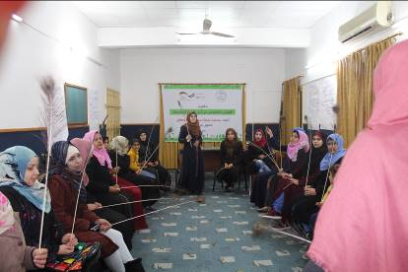
Twelfth project/ Economic Empowerment for Sustainability
- Date: 1/10/2017 – 30/9/2018
- Place: Gaza strip
- Beneficiaries: 60 women
- Fund: GIZ
- Budget: 152.425 Euro

- The activities implemented during the reporting period:
- Management, monitoring and evaluation the preparation and selection of the target group.
- Conducting (20) psychosocial support sessions for (60) young women victims of violence to improve well-being.
- Implementation of (10) sessions for 30 young victims of violence on the concept of gender, women's rights, communication skills, leadership and problem solving, teamwork, time management, creative thinking, self-affirmation.
- Conducting (90) consultation sessions for (60) victims of violence around various aspects of business administration.
- Networking with partners to assess additional services and transfer cases based on the needs of young women.
- Organizing (2) open days and recreational activities for women targeted.
- Implementation of vocational training (6 months) for (30) young victims of violence on sewing and embroidery, wool, cosmetics and hairdressing, design, printing and photography montage.
- Implementation of (2) home visit to assess the economic situation and follow the development of projects for the target group.
Conduct (30) hours for 30 women on how to start an income-generating project (entrepreneurship, feasibility study, financial management and marketing). During the training trainees will choose the preferred project for them and need the market and conduct a feasibility study for the project.
- The selection of (30) innovative creative project based on the criteria of transparency where they will be provided with financial grants.
- Financing (30) projects of the best projects in a financial amount (2000 Euro) for beneficiaries to start a small income-generating project.
- Organize (1) an event in which finance and lending associations are invited to provide financial opportunities to the beneficiary groups supporting their small projects.

Thirteenth project/ Financial aid to the wounded children
- Date: 1/1/2017 – 31/12/2017
- Place: Gaza Strip
- Beneficiaries: 37 wounds
- Fund: Gazzella
- Budget: 18.968 Euro

- The activities implemented during the reporting period:
- The distribution of financial aid to the wounded children, 50 euros per child, totaling 150 euros every three months
- Conducting follow-up home visits through the mobile mental clinic

Fourteenth project/ For a life without violence
- Implementation Date: 2017 to 2018
- Locations: All Governorates of Gaza Strip
- Number of Beneficiaries :15 women victims of GBV
- Financier: Gazzella-onlus WILPF-Italia
- Budget: 23,571.19 €
The objective of this project is for Palestinian women to be empowered so that they live a life free of violence and take the advantage from personal and professional development.
the continued efforts for the Individual empowerment program aims to contribute in building the capacity of women targeted 15 women, also to help these women to find appropriate jobs opportunities in CSO and private sectors after receiving the training, moreover to participate in public life (voluntary work, own private small business, membership in trade unions and participate in elections).

Major achievements during 2017
1. Aisha obtained the certificate of commitment to the Code of Conduct for Palestinian NGOs for two years. This certificate was granted on the basis of an evaluation carried out by the NGO Development Center. This certificate was accompanied by a capacity building plan for Aisha that is in line with the needs of the coming years.
2. Obtain the license of Aisha Community Center for Mental Health and Addiction Treatment and develop the protocol of the center in addition to the implementation of 100 training hours for the staff of Aisha and related institutions on the protocol.
3. Develop a manual to individual empowerment of women victims of violence and to transfer Aisha experience to the centers of women's centers so that the service is provided to women in different areas. In addition to cooperating with the "safe Shelter" to build the capacity of its staff and develop a guide to internal procedures in line with human rights and requirements of support and empowerment of women.
4. Establish a research department and issue (3) qualitative research on access to justice and measure the attitudes of men and boys about violence against women and promotion of gender.
5. Use new methodologies and tools to integrate men and boys to combat violence against women and promote gender through the formation of men (ambassadors of violence against women) to be the agents of change in communities and able to influence men and boys at different levels
6. Issuing new and quality training manuals: 1) Hawwa Al-Zahra manual to providing mental health and psychosocial services to women and girls who are victims of violence during crises. 2) manual to respectful confrontation to develop men's skills in understanding the real and masculine power and build listening skills and building safe spaces for difficult dialogues. 3) Bermundo manual to integrating men and boys against violence against women.
7. Building the capacity of Aisha in administrative and professional areas through training the staff on new skills and developing procedures, policies and plan and the use of administrative and professional experts to support the provision of quality services that respond to the needs of beneficiaries and funding requirements.

Challenges
1. The lack of funding to Palestine and the Gaza Strip in particular, and the high competition for fundraising, in addition to the requirements of renewable funding, which require high skills and do not unload a special staff for this purpose, is a great burden on executive management and administrative staff.
2. Aisha depends to provide its services in connection with the projects. The lack of centralized funding for Aisha to provide comprehensive services for humanitarian cases affects the quality of service.
3. The continued blockade and the obstruction of Palestinian reconciliation has increased the burden in the light of the worse humanitarian crisis, which made Aisha sometimes unable to perform services with high quality.
4. Poor coordination between government institutions and specialized service providers to provide additional services in the provision of services of livelihood and relief.
5. The difficulty of providing and obtaining statistics on the various forms of violence against women in the Gaza Strip, which emphasizes the need for a specialized research and documentation department.
6. Increasing the demand for legal clinic because of the seasonal work in the partner clinics and transfer cases to the legal clinic in Aisha, which increases the financial burden due to the suspension of funding the clinic from UNDP

Future Needs
- Unrestricted funding that will contribute to ensure the stability of the association, which will support the quality improvement and long-term planning of the association.
- An independent building owned by the association reduces the financial burden and creates new opportunities for the association's income.
- Membership in international networks ensures representation of the association at the international level and allows it to access and share experiences with governmental and international organizations.
- The need of a consultant for funds with an independent department of projects of funds and international relations and management of human resources that will improve the work within Aisha and respond to the rapid development in the quantity and quality of work.
- 8. Raise the efficiency and development of the capacities of women professionals and its specialization in the field of research and psychological support, legal and professional women, which contributes to raise services and programs provided to women.

